

COLLEGE NAME: PRIYADARSHINI ENGINEERING COLLEGE

COLLEGE CODE : 5119

COURSE NAME: Internet Of Things (IOT)

GROUP NUMBER: 2

PROJECT TITLE: PUBLIC TRANSPORTATION OPTIMIZATION.

PROJECT SUBMITTED TO: SKILL UP ONLINE

YEAR: 3rd

DEPARTMENT: ELECTRONICS AND COMMUNICATION ENGINEERING.

SEMESTER: 5th

GROUPMEMBERS: PRAVEEN.SR [511921106022]

SANTHOSH.AR [511921106029]

HARISH.K [511921106007]

MUGUNDHAN.P [511921106018]

GUIDED BY: Dr.A.BANUPRIYA.HOD/ECE

SPOC NAME: Dr.R.THENMOZHI.HOD/EEE

**INNOVATION :**

* Integrate loT sensors in public transportation vehicles to monitor ridership, track locations, and predict bus or train arrival times. This data can be shared on a public platform to improve transit services.
* Use sensors such as GPS sensor to monitor location of each vehicle.
* This information is then fed to Arduino and then uploaded to cloud using an esp8266 module.
* This information is then used to monitor the locations of the public vehicle. Scheduling public transport making information available to the users.

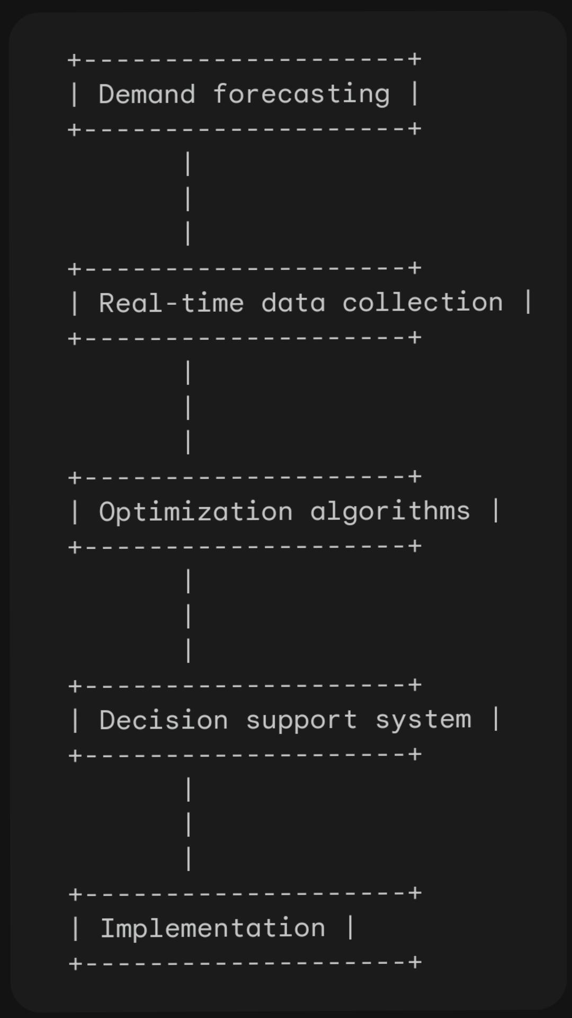**BLOCK DIAGRAM :**

**DESCRIPTION:**

**1.Demand forecasting:**

* The demand forecasting block uses historical data, surveys, and travel modeling to predict the number of passengers who will use the public transportation system at different times and locations.

**2.Real-time data collection:**

* The real-time data collection block collects data from a variety of sources, such as GPS sensors, passenger counters, and social media, to update the demand forecast and to identify real-time disruptions to the system.

1. **Optimization algorithms:**

* The optimization algorithms block uses the demand forecast and real- time data to generate a set of recommendations for improving the performance of the public transportation system. These recommendations may include changes to vehicle schedules, routes, and frequencies.

1. **Decision support system**:

* The decision support system block presents the recommendations from the optimization algorithms block to the transportation operators, who can then make decisions about how to implement them.

1. **Implementation**:

* The implementation block involves putting the changes recommended by the optimization algorithms block into effect. This may involve updating vehicle schedules, adjusting route maps, and communicating the changes to passengers.